**Assignment 4 Pictures**

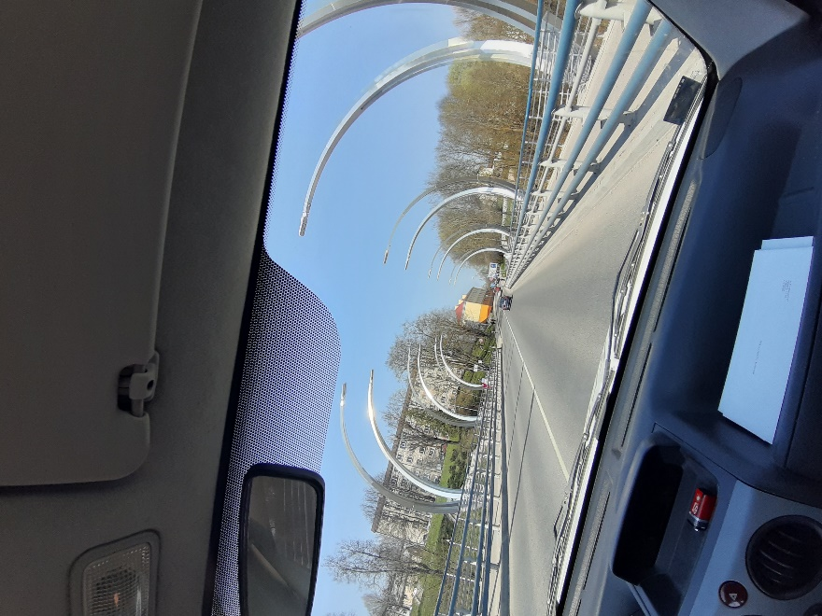**The Framing**: The frame was taken from the car to make it stand out from the standard bridge photo. It was also taken in a moving car.

**The angle:** The angle is not really thought out, but the picture may show that the picture is slightly slanted.

**The lights:** As it was sunny outdoors, there is really nothing to add to the lighting in this picture. Everything is bright, well understood and has small shadows.

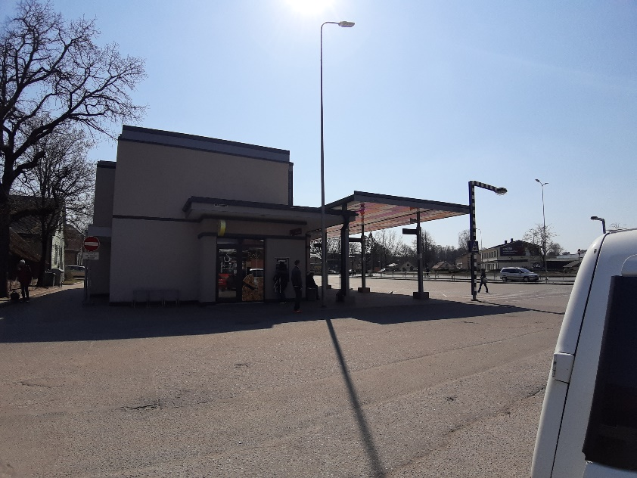**The Framing:** The frame was made to cover the entire bus station and be in the middle of the frame.

**The angle**: A picture was taken with a wide-angle camera that allows you to take pictures with a wider angle.

The picture itself is made as straightforward as possible so that the building does not look inclined in the picture.

**The lights**: So, there is a sun directly at the top, so many shadows can be seen from the building's starting point.